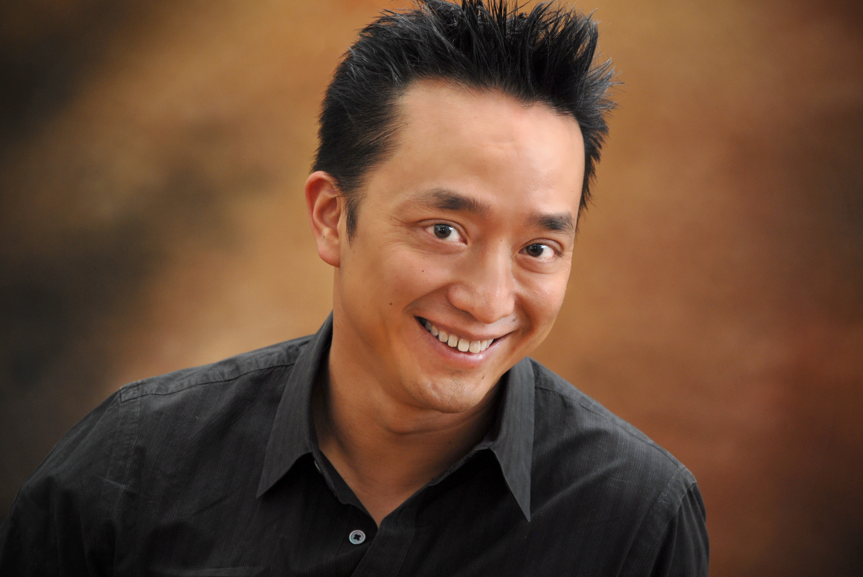
Heralded for his “powerfully expressive voice” (Washington Post), and “a superb singer . . . with a soaring voice in the extreme registers that could be simply described as amazing” (New York Concert Review), Stephen Ng is known as an opera, oratorio, recital, and new music performer. His portrayal of Evangelist in Bach’s Passions has received much acclaim, and he has performed as soloist with Philharmonia Baroque Orchestra, De Nederlandse Opera, Orchestra Iowa, Washington Bach Consort, and Lucerne, Tanglewood and Aspen Festivals, working with conductors such as James Levine, Nicolas McGegan, and Pierre Boulez.
His CD Janáček’s The Diary of One Who Vanished was released by Clear Note Publications. Of this, Journal of Singing writes “Ng, a tenor with an impressively eclectic resume, is simply superb in every respect. His voice is gorgeous and distinctive.” His second CD, titled A Soft Florida Rain: Ng sings Juusela, was released in 2013.
Stephen began his vocal training in Hong Kong and subsequently received his M.M. at New England Conservatory and D.M. at Indiana University. He has taught at Florida’s Stetson University, and is currently Associate Professor at West Chester University of Pennsylvania.

吳智誠
男高音

吳智誠擅長歌劇、聖樂、獨唱及新音樂，精湛歌藝曾獲《華盛頓郵報》及《紐約樂評》讚賞。他演繹巴赫《受難曲》中的傳道者，表現備受好評。過往獨唱演出包括：愛樂巴洛克樂團、荷蘭歌劇團、愛荷華交響樂團及華盛頓巴哈室內樂團，琉森音樂節、鄧肯活音樂節、美國科羅拉多州阿斯蓬音樂節等，與利雲、麥基根、布萊茲等知名指揮家合作。

他在首張專輯中演繹楊納傑克的《失蹤者的日記》，由Clear Note Publications發行，獲《歌唱期刊》評為「風格兼收並蓄，各方面均出類拔萃，聲音獨特動聽」。他最近推出第二張專輯《佛羅里達的雨絲－吳智誠演繹尤塞拉》。

吳智誠的聲樂訓練始於香港聖保羅書院，他當時是合唱團活躍成員。1995年，香港中文大學一級榮譽畢業，先後於新英格蘭音樂學院取得音樂碩士及印第安納大學音樂博士。他曾於佛羅理達州史丹森大學擔任助理教授，目前於賓夕法尼亞洲西切斯特大學任教。

